**How To Install and Use Jenkins on Ubuntu 16.04 & 14.04 LTS**

[Jenkins](https://jenkins.io/) is an automation server and continuous integration tool. It provides a number of plugins for building deployments and automation for your applications. You can use Jenkins as a simple CI (Continuous Integration) server or configure this for the CD (Continuous Delivery) hub for any number of the projects. With the help of Jenkins, you can easily distribute work across multiple machines, helping drive builds, tests and deployments across multiple platforms faster.

This tutorial will help you to install and use Jenkins on Ubuntu 16.04 LTS & 14.04 LTS systems.

**Step 1 – Add Jenkins PPA**

Jenkins is available in two versions. One is LTS release provides long-term support and other provides the latest version. We preferred to use LTS version for production use and the latest version for development or testing. You can use any of version of your choice below.

**Add LTS Version PPA**

wget -q -O - https://pkg.jenkins.io/debian/jenkins.io.key | sudo apt-key add -

sudo sh -c 'echo deb http://pkg.jenkins.io/debian-stable binary/ > /etc/apt/sources.list.d/jenkins.list'

**Add Latest Version PPA**

wget -q -O - https://pkg.jenkins.io/debian/jenkins.io.key | sudo apt-key add -

sudo sh -c 'echo deb http://pkg.jenkins.io/debian-stable binary/ > /etc/apt/sources.list.d/jenkins.list'

**Step 2 – Install Jenkins**

Now update your apt-get cache and install Jenkins using the following commands.

sudo apt-get update

sudo apt-get install jenkins

After installation Jenkins start on port 8080. In my case port, 8080 was busy in some other process so edited /etc/default/jenkins and update HTTP_PORT to 8081.

HTTP_PORT=8081

and restarted Jenkins service again

sudo service jenkins restart

**Step 3 – Access Web Interface**

Now access your server on port **8080** (in my case 8081) in your favorite web browser. Default installation password can be found at **/var/lib/jenkins/secrets/initialAdminPassword** as showing in below image.

[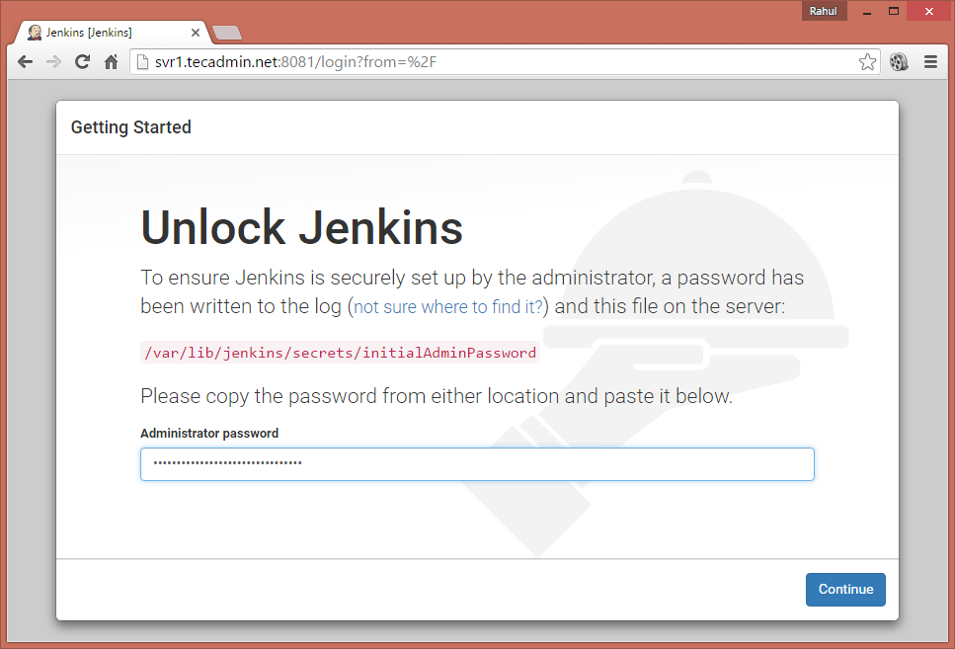](https://tecadmin.net/wp-content/uploads/2016/05/jenkings-install-1.png)

Now select appropriate option to install the plugin. You can choose to install suggested plugins or select required plugins options.

[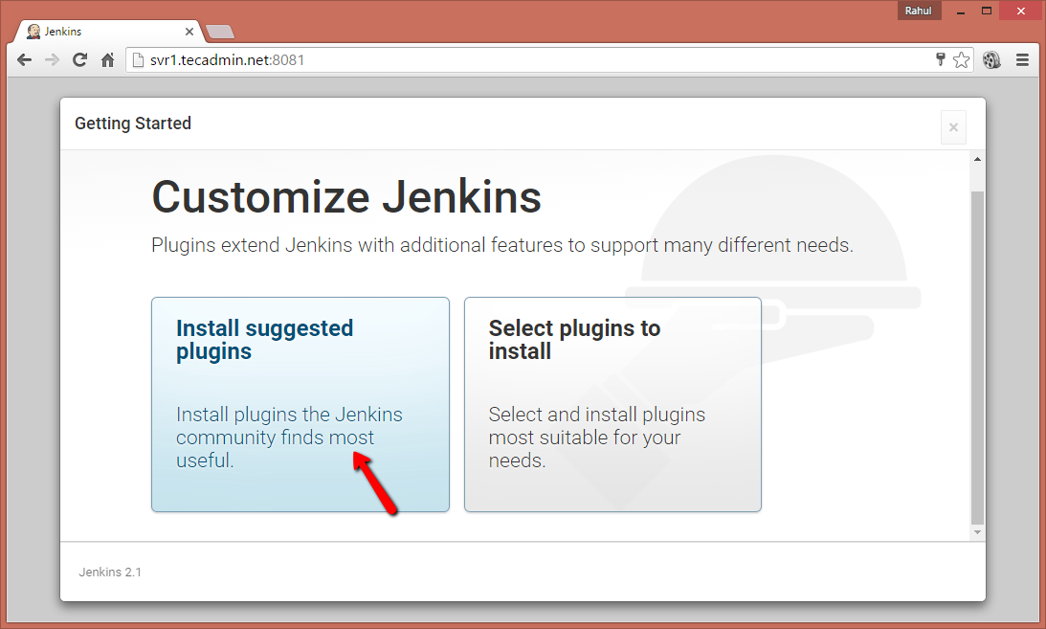](https://tecadmin.net/wp-content/uploads/2016/05/jenkings-install-2.png)

Now create an admin account for your Jenkins setup. This will be required to log in to Jenkins.

[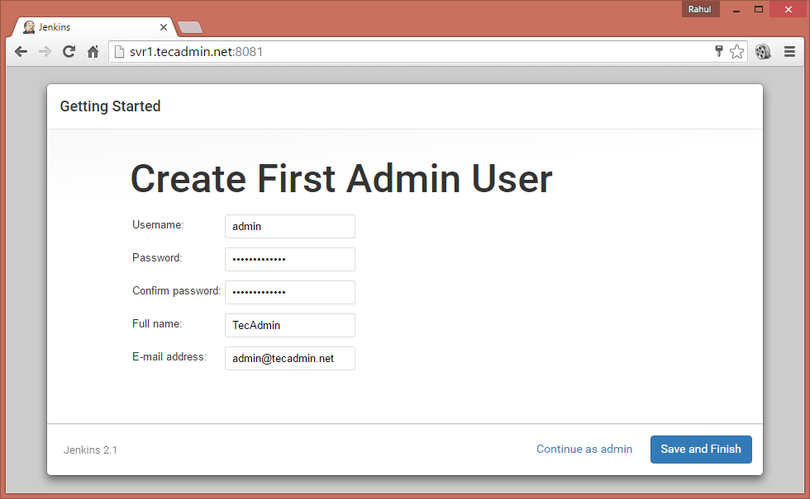](https://tecadmin.net/wp-content/uploads/2016/05/jenkings-install-3.png)

After successful completion of Jenkins setup wizard, You will be redirected to Jenkins dashboard.

[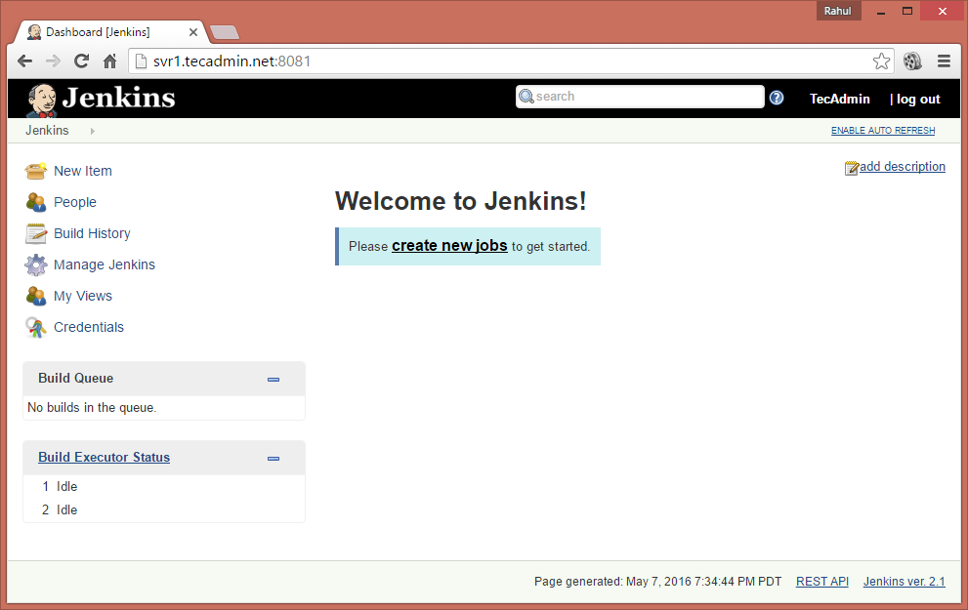](https://tecadmin.net/wp-content/uploads/2016/05/jenkings-install-4.png)

**Step 4 – Install Plugins in Jenkins**

Login to Jenkins dashboard and navigate to **Manage Jenkins >> Manage Plugins >> Available Tab** and select the plugins to install.

[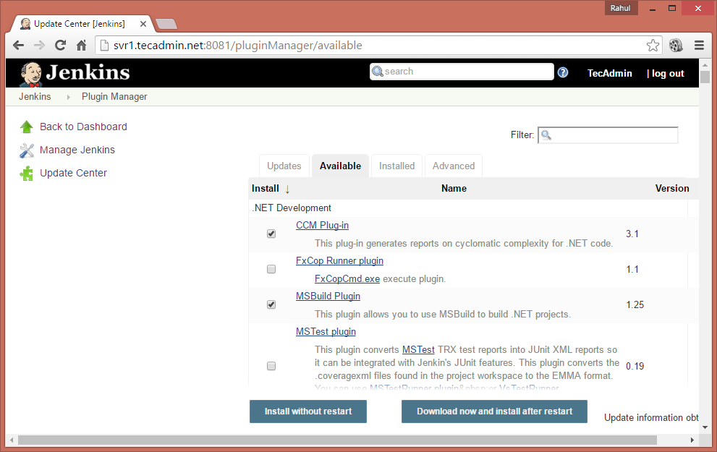](https://tecadmin.net/wp-content/uploads/2016/05/jenkings-plugin-install.png)

To update existing installed plugins in Jenkins **Manage Jenkins >> Manage Plugins >> Update Tab**

**Step 5 – Create Users in Jenkins**

To create users in Jenkins login to Jenkins admin panel and navigate to **Manage Jenkins >> Manage Users >> Create User**. Enter the required details and click Create User.

[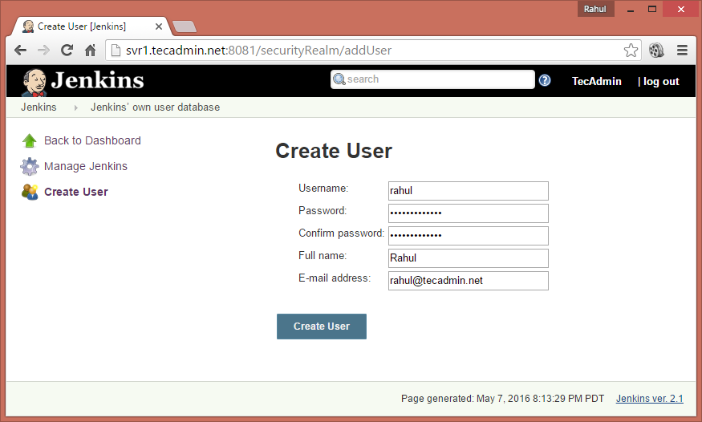](https://tecadmin.net/wp-content/uploads/2016/05/jenkings-create-user.png)